**NTOMBI ANNA M**

Brightlight Data Analytics Coding Practical Practical 2.1 :

Advanced SQL The following questions are designed to help you build a strong foundation in basic SQL syntax. You are provided with a dataset named shoping_trends.csv. Upload this dataset to your Snowflake account and use it to answer the questions below. Please follow the instructions below carefully:

1. Find all records where Size is missing and the purchase amount is greater than 50. Expected Columns: Customer ID, Size, purchase amount, Item Purchased

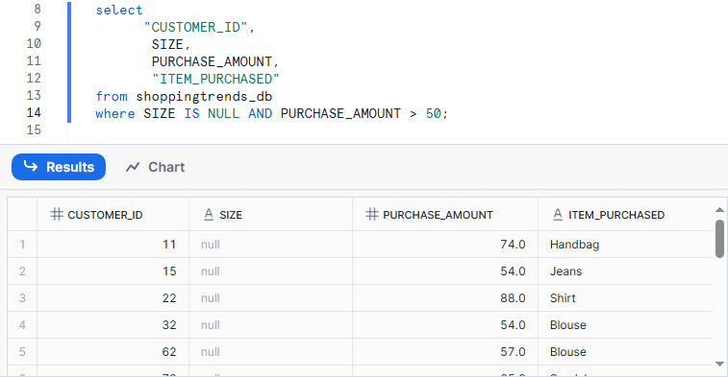

1. List the total number of purchases grouped by Season, treating NULL values a s 'Unknown Season'. Expected Columns: Season, Total Purchases

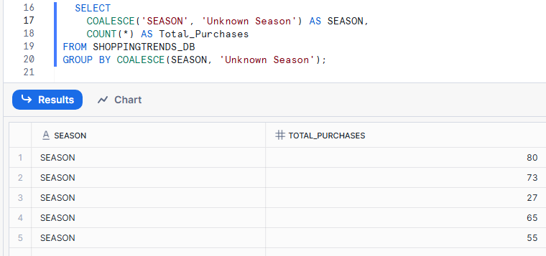

1. Count how many customers used each Payment Method, treating NULLs as 'Not Provided'. Expected Columns: Payment Method, Customer Count

1. Show customers where Promo Code Used is NULL and Review Rating is below 3.0. Expected Columns: Customer ID, Promo Code Used, Review Rating, Item Purchased

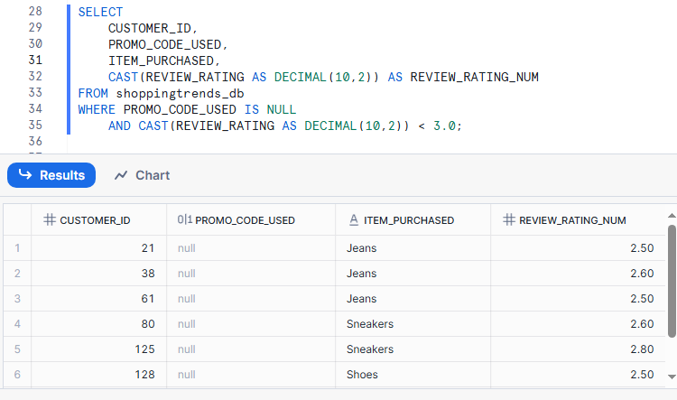

5. Group customers by Shipping Type, and return the average purchase_amount, treating missing values as 0. Expected Columns: Shipping Type, Average purchase_amount

1. Display the number of purchases per Location only for those with more than 5 purchases and no NULL Payment Method.

Expected Columns: Location, Total Purchases

7. Create a column Spender Category that classifies customers using CASE: 'High' if amount > 80, 'Medium' if BETWEEN 50 AND 80, 'Low' otherwise. Replace NULLs in purchase_amount with 0. Expected Columns: Customer ID, purchase_amount, Spender Category

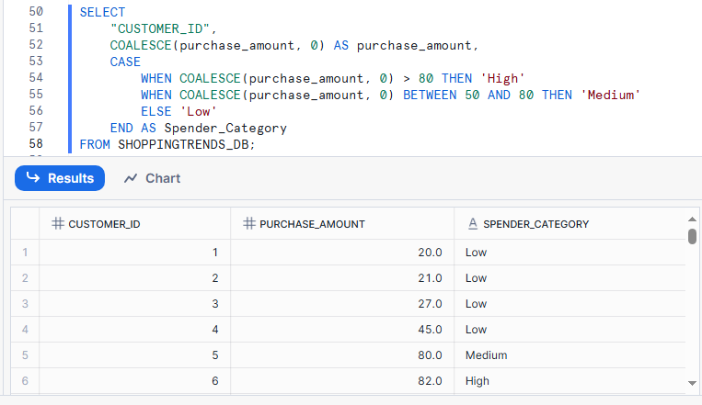

8. Find customers who have no Previous Purchases value but whose Color is not NULL. Expected Columns: Customer ID, Color, Previous Purchases

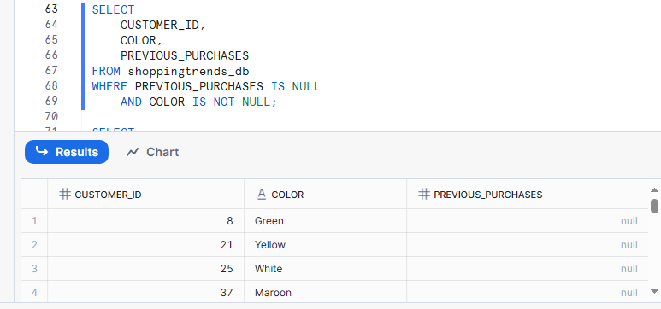

9. Group records by Frequency of Purchases and show the total amount spent per group, treating NULL frequencies as 'Unknown'. Expected Columns: Frequency of Purchases, Total purchase_amount

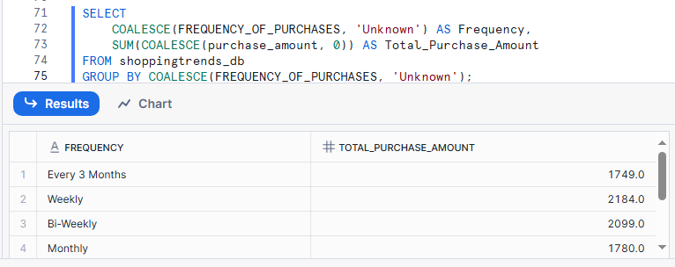

10. Display a list of all Category values with the number of times each was purcha sed, excluding rows where Categoryis NULL. Expected Columns: Category, Total Purchases

11. Return the top 5 Locations with the highest total purchase_amount, replacing NULLs in amount with 0. Expected Columns: Location, Total purchase_amount

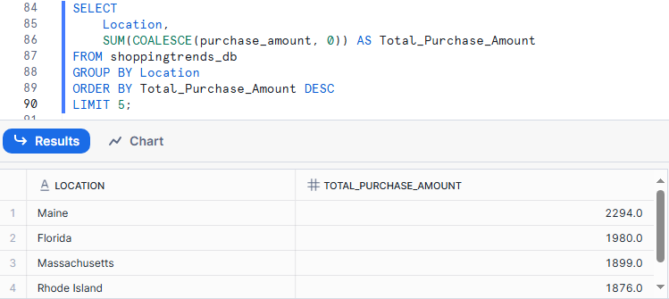

12. Group customers by Gender and Size, and count how many entries have a NUL L Color. Expected Columns: Gender, Size, Null Color Count

13. Identify all Item Purchased where more than 3 purchases had NULL Shipping Type. Expected Columns: Item Purchased, NULL Shipping Type Count

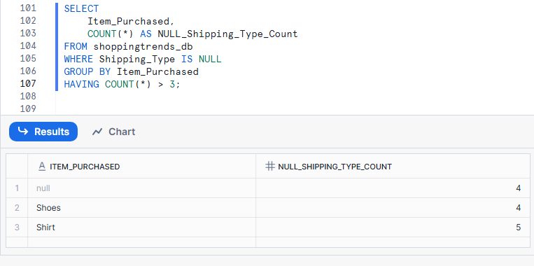

14. Show a count of how many customers per Payment Method have NULL Review Rating. Expected Columns: Payment Method, Missing Review Rating Count

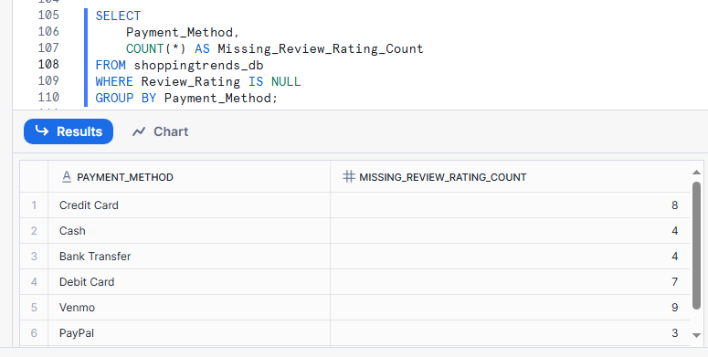

15. Group by Category and return the average Review Rating, replacing NULLs with 0, and filter only where average is greater than 3.5. Expected Columns: Category, Average Review Rating

16. List all Colors that are missing (NULL) in at least 2 rows and the average Age of customers for those rows.

17. Use CASE to create a column Delivery Speed: 'Fast' if Shipping Type is 'Express' or 'Next Day Air', 'Slow' if 'Standard', 'Other' for all else including NULL. Then count how many customers fall into each category. Expected Columns: Delivery Speed, Customer Count

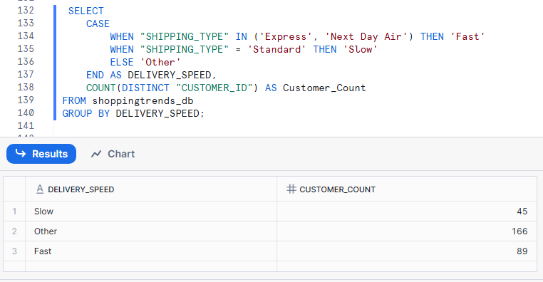

18. Find customers whose purchase_amount is NULL and whose Promo Code Used is 'Yes'. Expected Columns: Customer ID, purchase_amount, Promo Code Used

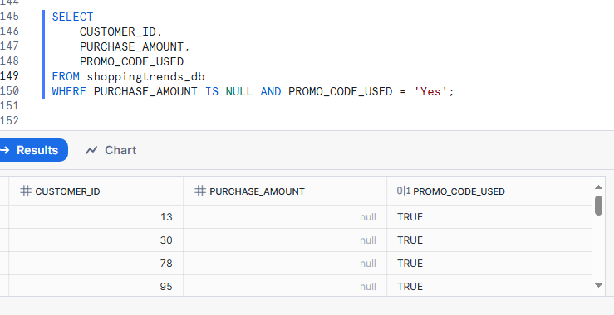

19. Group by Location and show the maximum Previous Purchases, replacing NULLs with 0, only where the average rating is above 4.0. Expected Columns: Location, Max Previous Purchases, Average Review Rating

20. Show customers who have a NULL Shipping Type but made a purchase in the range of 30 to 70 USD.

